Section 6 Axis Systems and Transformations
6.1

6.2
6.3

6.4

6.5
6.6
Earth Axis Systems

Aircraft Axis Systems
Body, Stability, Wind, Principle

Euler Angles

Flight Path Angles

Axis System Transformations
Earth-to-Body, Body-to-Earth

References
Page 06 - 1
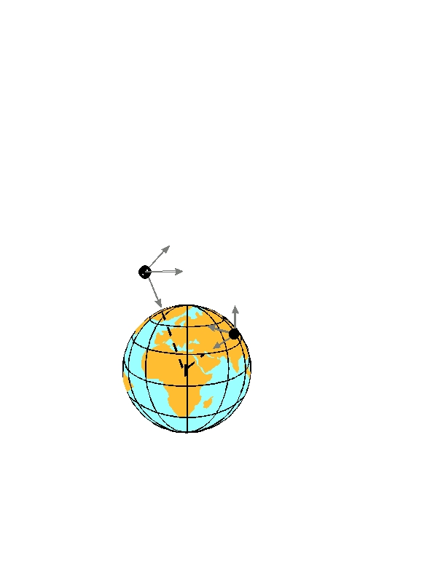6.1 Earth Axis Systems (ref 6.6.1)

Both fixed-Earth and moving-Earth axis systems keep constant orien-
tation with respect to the Earth. The Z-axis point towards the center of
the Earth.
•

•
The origin of a fixed-Earth system does not move relative to the
Earth. (such as a ground radar site)
The origin of a moving Earth system does not move relative to its
host (such as an aircraft inertial reference unit) .
X
Moving
Earth
Axes
Y
Z
X
Z
XY plane is horizontal

Y
Fixed
Earth
Axes
Page 06 - 2
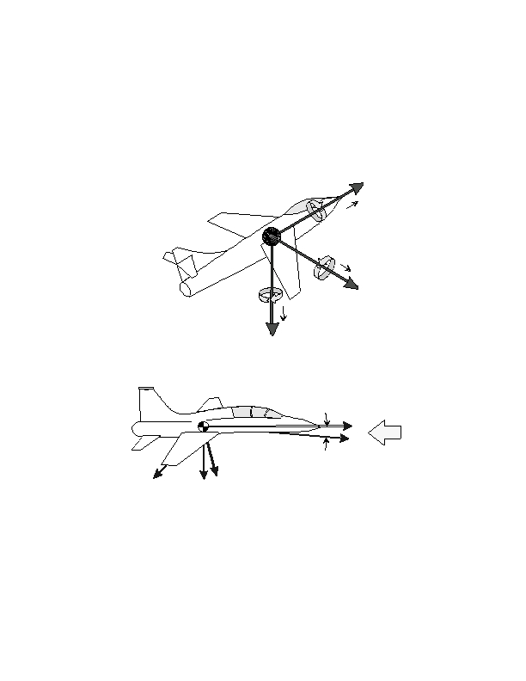6.2

•
Aircraft Axis Systems (ref 6.6.2)

The body axis system originates at the aircraft's reference center of
gravity. The + bx direction is towards the front, the +y b direction is
towards the right wing tip, and the + bz direction is towards the bot-
tom of the aircraft.
xb
u
x
a
p

is
y
a
x
x
is
q
v
r
yb
w
zb
The stability axis system is similar to the body axis system except
that it is rotated about the y-axis through the angle of attack ()
•
x
x
b

s
RW

y , y
s b
z
b
z
s
Forces, velocities or accelerations along the stability axes are related to
the body axes as follows
xb
zb
yb
= x s cos z sin
= z s cos + x sin
= ys

Page 06 - 3
s
s
z
a
x
i
s
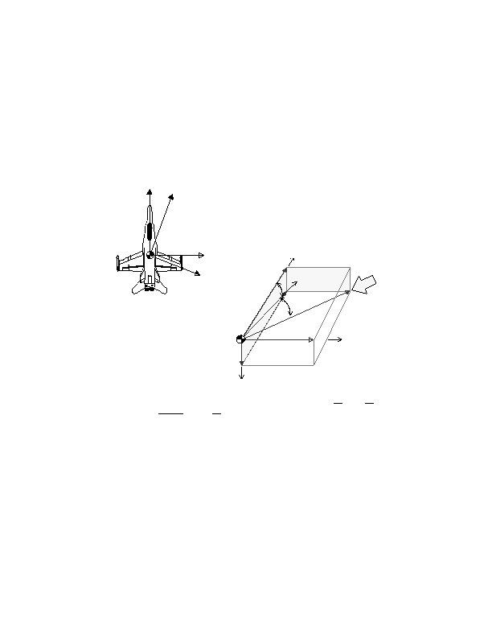•
The wind axis system is similar to the stability axis system except
it is rotated about the z s axis through the angle of sideslip ().
The term "wind" refers to the fact that the freestream relative wind
approaches the aircraft directly along the x w axis. This dictates that the
true airspeed also lies along the x w axis.
x
s
x
w
Forces, velocities or accelerations
along the wind axes are related to the
stability axes as follows
xs
ys
zs
= x w cos y sin
= y w cos + x sin
= zw
w
w
x
b

y
y
s

w
x
s
R
W

v
u
V
x
w
T
The geometric relations be-
tween body, stability and wind
axis velocities are illustrated
here.
y
b
w
z
b

if is small, then

if is small, then
sin =

V T cos
, sin =
V
V
T
sin =

=

V
T

V
T
, =
V
V
T
Most aircraft sideslip vanes do not measure directly. They measure
the flanking angle, which is the projection of the relative wind into the
aircraft's x-y plane. The difference between these two angles increases
with angle of attack. Ignoring upwash, boom bending, and body axis
rate corrections, calculate true sideslip as a function of vane and as
follows:
true
-1
= tan
[ tan( vane ) cos ]

Page 06 - 4
•
Wind-Body Axis Transformations (ref 6.6.1)
Combining the two previous transformations, forces, velocities or ac-
celerations along the wind axes are related to the body axes as follows

x b  cos 0 sin cos sin 0 x W 
  
b 
y =

0
1
0
 
 
sin
0
 
 
y
W 
z  sin 0
  
b

After expansion,
cos   0
 
xb
yb
zb
cos
0
1 z 
  W
= cos ( wx c os - y sin) - z sin
= x wsin + y cos
= sin ( wx c os - y cos) + z cos
w
w
w
w
w
The inverse transform, converting from the body to the wind axis sys-
tem is
 Wx   cos


 
y
W  
sin 0  cos
0 sin  x b 
1 0
  
y
  b 
= sin cos 0
 
 
0
ζ W   0

After expansion,
 
xw
yw
zw
0
1  sin 0 cos z 
 
  b 
= cos ( bx cos + z sin) + y sin
= -sin ( bx c os+z sin)+ y cos
= - bx s in + z cos
b
b
b
b
b
Note that these equations apply to the sign convention with z+ down. If
sign convention (and instrumentation calibration) use z+ upward, then the
above equations become:
xw
yw
zw
= cos(x bcos - z sin) + y sin
= -sin(x bcos + z sin) + y cos
= x bsin + z cos
b
b
b
b
b
Page 06 - 5
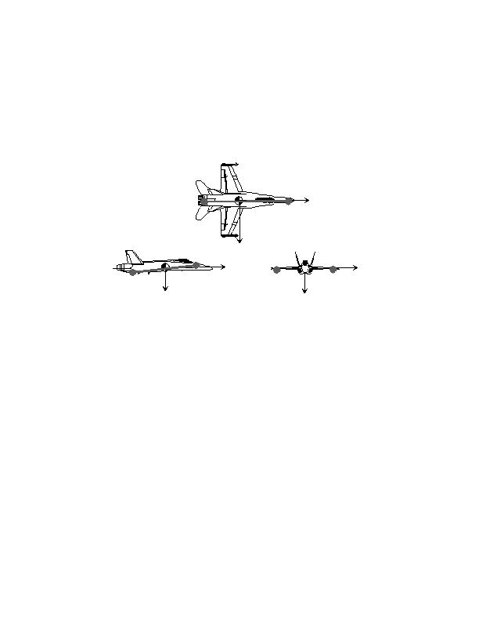•
The Principle axes are those about which the products of inertia are
zero. They can be equated to the axis of "dumbells" which repre-
sent concentrated mass elements. Neglecting aerodynamic and gy-
roscopic effects, an aircraft rotating about one of its principle axes
will not tend to cross-couple into motion about any other axis.
x
y
x
y
z
z
Wind to Body Axes Matrix Transformation
Page 06 - 6
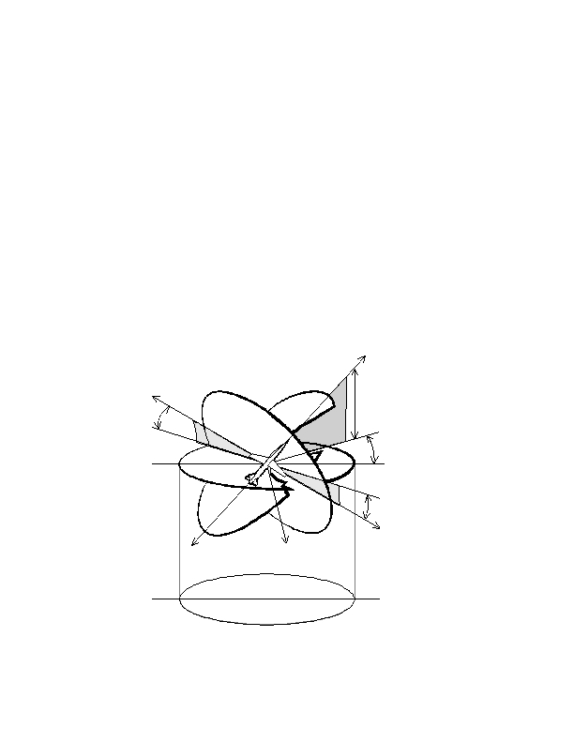6.3 Euler Angles (ref 6.6.1)

Euler angles are expressed as yaw, pitch, and roll. The sequence: first
yaw, then pitch, then roll; must be maintained to arrive at the proper
orientation angles. The Euler angles are defined as follows:

Yaw Angle: The angle between the projection of the vehicle
xb- axis onto the horizontal reference plane and some initial
reference position of the Earth x-axis. Yaw angle equals the
vehicle heading only if the initial reference is North.

Pitch angle (in vertical plane) between x b and horizon.

Bank angle, the angle (measured in the y-z plane of the body-
axis system) between the y-axis and the horizontal reference
plane. Also known at the roll angle, it is a measure of the rota-
tion (about the x-axis) to return the aircraft to a wings level con-
dition.
x

+

+
y
z
Earth Plane
Page 06 - 7
6.4 Flight Path Angles (ref 6.6.3)
Just as the Euler angles define the attitude of the aircraft with
respect to the Earth, three flightpath angles describe the vehicle's cg
trajectory relative to the Earth (not the air mass).

∝
= Flight path heading angle; also known as ground track heading, is
the horizontal angle between some reference direction (usually
North) and the projection of the velocity vector on the horizontal
plane. Positive rotation is from North to East.
= Flightpath elevation angle; the vertical angle between the flight-
path and the horizontal plane. Positive rotation is up. During a
descent, this parameter is commonly known as glide path angle.
= Flightpath bank angle; the angle between the plane formed by
the velocity vector and the lift vector and the vertical plane con-
taining the velocity vector. Positive rotation is clockwise about
the velocity vector, looking forward.
The first two parameters above are easily measured using ground-based
radar, or onboard GPS or inertial reference systems. If only , , and
the Euler angles are available, then assuming zero winds, the flight-
path angles can be calculated as

= sin [(sin cos cos cossin)cos cos sinsin
1
= sin [
1
cos sin sin sin cos
cos
] +
∝ = sin [
1
cos sin cos + (sin cos cos cos sin ) sin
cos
]
Technically, the above equations describe the velocity vector (angles
relative to the air mass). If the air mass is moving relative to the Earth,
as is usually the case, the above equations do not describe the flight-
path.

Editor's note: not knowing the difference between flightpath and velocity vec-
tor angles can cause considerable confusion when analyzing data from differ-
ent sources.
Page 06 - 8
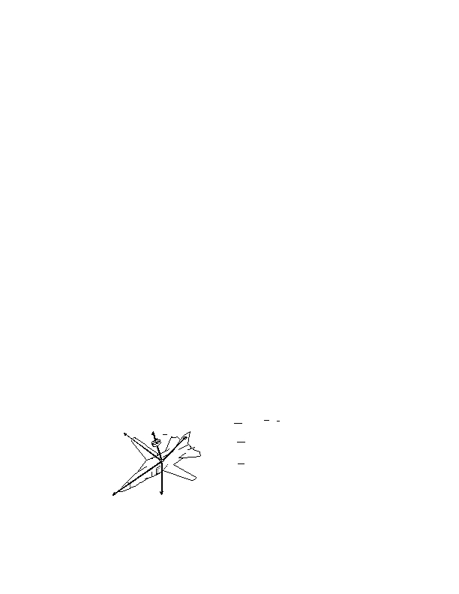6.5 Axis System Transformations (ref 6.6.2)

Transformation matrix for converting forces, velocities or accelerations
from inertial (X, Y, Z) to body (x, y, z) axes
 x 1
  
  
y = 0
 z  0
  
0
cos
0  cos 0 sin   cos
sin
 
 
0
1
0
 
 
sin
0 X 
sin cos 0
  
  
Y
sin cos  sin 0
 
cos   0
 
0
1  Z 
  
x 
  
  
y
cos cos
cossin
sin   X 
= cos sin +sinsin cos coscos +sinsinsin sincos
  

Y
 
z  sinsin +cossin cos sincos +cossinsin coscos  
  

 Z 
The inverse of the above transform matrix converts
from the body axis to the inertial axis coordinate system

X cos cos cossin +sinsin cos sinsin +cossin cos  x
  
  
Y = cossin coscos +sinsinsin sincos +cossinsin
Z  sin
  
sincos
coscos
  
y
  
 z
  
Acceleration Transformations
•

•
Convert body-axis angular rates & linear accelerations into total
accelerations along body axes.
Convert element (m 1) location & rates into specific angular momen-
a
a
a

y
= u +
= v +
& ru
= w +
x

y

z
& qw rv
pw
& pv
qu

H = r ⋅ [ ⋅ r ]⇒
1
1`
= p (y + z
2
m
Expand-  H  a
ing
gives:
 m  l
 H  n
 m  y
 H  n
 m  k
 
 


2
m
1
r
1
) q(xy ) r(xz )
⇒
= q (x + z ) r(yz) p(xy)

= (ρ x + y ) p(xz) q(yz)
2
2
2
2
⇒
x
z
Page 06 - 9
Transformations between body axis rates and Euler angle rates
p
q
r
= & &sin
= &cos + &cos sin
= &cos cos &sin
&
&
= p + tan ( q sin + r cos )
= q cos r sin
& =
q sin + r cos
cos
Transformations from Euler & aerodynamic angles to the aircraft
stability and wind axis angular rates. Subscripts b, s, and w denote the
body, stability and relative wind axis systems.

( p s , q s , r s , p w, q w, r w ) = f ( p b , q b , r b , , )
p
q
r
s = p cos + r sin
b
p
q
r
w = p cos + q sin
s
s
s = q
b

b
s = r cos p sin
b
b
w = q cos p sin
s
s
w = r
s
Transformations from Euler angles to the three aircraft axis angu-
lar accelerations (ref 6.6.3)

( pb&, p&, p& , q&, q&, q&, r&, r&, r&) = f ( , & &&, ,, && &, , , && ,& ,α,&, β,)
b = & & &&σin && χο s
&
s
w
b
s
w
b
s
w
p&
q&
b = & & χos && σι n +ϕ&&χos sin && σι n sin + && χο s cos
r&
b =&&χos cos && σι n cos && χο s sin & & σin && χο s
p&
q&
s = pb& cos +& bp sin + rb&sin + b&r c os
s = qb&
r&
s = rb&cos b&r s in pb& sin & bp cos
p&
q&
w = ps& cos p s &sin + qs&sin + q s &cos
w = qs&cos q s &sin ps& sin p s &cos
r&
w = rs&
Page 06 - 10
6.6 References
6.6.1
6.6.2
6.6.3
Lawless, Alan R., Math and Physics for Flight Testers "Chapter 7,
Axis Systems and Transformations", National Test Pilot School, Mo-
jave CA, 1998.
Anon., Aircraft Flying Qualities, Chapter 4, Equations of Motion,
USAF TestPilot School notes, AFFTC Edwards AFB CA, March
1991.
Kalviste, Juri, Flight Dynamics Reference Handbook, Northrop Corp.
Aircraft Division, April 1988.
Page 06 - 11
NOTES
Page 06 - 12

